## More Puppets

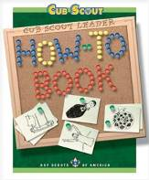How To Book p. 5 -- 12-24.

2010 Theme: “In the Spotlight”: <http://usscouts.org/bbugle.asp> Puppets: p. 30-33.

Games: p. 8-10; 36-8. Snacks: p. 39-40.

2003 “Lights, Camera, Action”:   
Baloo: Games: p. 3;12. Snacks: p. 9. <http://usscouts.org/bbugle.asp>

Santa Clara: Puppets: p. 11-12; 17. Games: p. 2-4; 15-16. Snacks: 17-18. Fun cookie puppet here.   
<http://www.macscouter.com/CubScouts/>

Deseret District: Games p. 1-2.   
<http://www.scoutingthenet.com/Training/Roundtable/Handouts/03/04/>

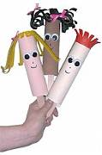  
<http://www.makingfriends.com/puppet_making.htm>

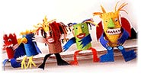 Juice Can Puppets:   
<http://familyfun.go.com/crafts/juice-can-puppets-665085/>

***[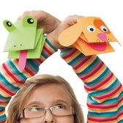](http://familyfun.go.com/assets/cms/crafts/paper-puppets-craft-photo-420-FF0810EFA10.jpg)*** Paper Puppets:   
<http://familyfun.go.com/crafts/paper-puppets-909092/>

***[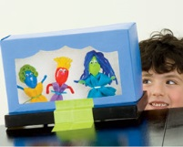](http://familyfun.go.com/assets/cms/crafts/spoon-actors-guild-craft-photo-420-FF0509EFA08.jpg)***

Recycled Puppet Theater & Plastic Spoon Puppets: <http://familyfun.go.com/crafts/spoon-actors-guild-675384/>

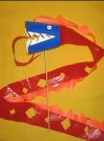 Dragon Puppet:   
Cut 2 wedges (v shapes) out of the sides of a paper or plastic cup to create the open mouth of the dragon. Using a nail, punch a hole in the top and bottom of the dragon. Slide a skewer through the holes so the dragon sits on the stick like a lollipop. Decorate the dragon with eyes, teeth, and an optional tongue. Tape a long ribbon(s) to the cup for the tail. (I used plastic surveyor’s tape, and cut points on the top ribbon and diamonds in the middle of the bottom ribbon. You can also use strips of plastic cut from a cheap plastic tablecloth.) The boys will have fun waving their puppets around, and watching the tails flutter and stream out behind the dragon. *From The Picture Book of Kids’ Crafts*

 Edible Cookie Puppets:   
<http://familyfun.go.com/recipes/cookie-crafts-for-kids-714703/>